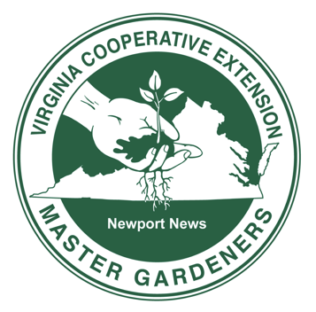

Newport News Master Gardeners Association
Horticulture Grant
2023 – 2024 School Year

Purpose
Newport News Master Gardeners Association (NNMGA) Horticulture Grants are designed to foster and support the development of student-based projects within both public and private Newport News schools that reflect the Virginia Master Gardener mission of enhancing horticultural awareness and the environment. These grants are designed to provide seed money for on campus projects that increase student understanding and appreciation of the role of plants and gardening in the local ecosystem and on their campus. Student centered and hands on projects are strongly encouraged.

Eligibility
Grants are available to teachers of all content areas in both public and private schools in Newport News. All levels of schools are eligible to apply for the grants.

Size of Grants
NNMGA Horticulture Grants may be funded up to $500.

Application Timeline
Applications can be found at nnmastergardeners.org. Completed applications may be submitted either electronically or by mail and are due by June 1, 2023. Approval of Grants will be announced by June 15, 2023, and funds will be made available on August 15, 2023.

Responsibilities of Grant Recipients
Recipients will be responsible for ensuring approval of projects by their campus Administrator. Upon completion of the project or the end of the 2023 – 2024 school year, recipients will submit a final evaluation of the project and a description of how funds were utilized.
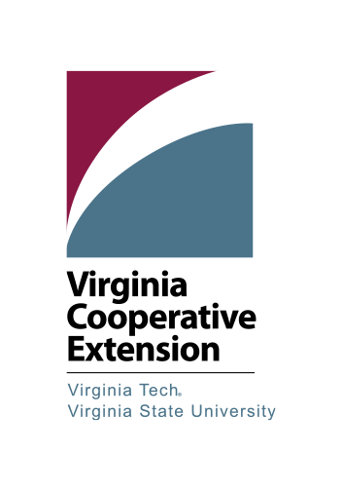
Virginia Cooperative Extension is a partnership of Virginia Tech, Virginia State University, the U.S. Department of Agriculture, and local governments. Its programs and employment are open to all, regardless of age, color, disability, gender, gender identity, gender expression, national origin, political affiliation, race, religion, sexual orientation, genetic information, military status, or any other basis protected by law.

_____________
Application Number
(NNMGA use)

Newport News Master Gardeners Association
Horticulture Grant
School Year 2023-24

Title of Project:

Teacher or Project Leader’s Name:

Email Address: Phone Number:

School name and complete mailing address:

ALL personnel involved with the project will sign below. The signature(s) certify the following:
• All information in this application is correct.
• This proposal has been reviewed and the submission authorized by the building principal.
• No funding is requested for personnel or field trips.
• A final report using the project summary form and pictures will be submitted at the conclusion of the project or by May 30, 2024.
• Permission is given to Newport News Master Gardeners Association and Virginia Cooperative Extension to use this information for the purposes of news and publicity in all media, including but not limited to print, electronic media and Internet web sites.

Applicant signature:______________________________________ Date _______________
Applicant signature:______________________________________ Date _______________
Applicant signature:______________________________________ Date _______________
Applicant signature:______________________________________ Date _______________
Principal: By signing this page, I confirm that I have read through the application, the project can be completed at my building and this grant does not ask for the funding of items that are currently funded within instructional budgets of the school. I am aware that the NNPS Landscape Supervisor must approve any outdoor projects.

Principal’s Signature:___________________________________ Date_______________

DEADLINE: JUNE 1, 2023

_______ _____________
Public or Private Application Number
(NNMGA use) (NNMGA)

PLEASE DO NOT IDENTIFY TEACHERS OR SCHOOLS ON THE NEXT TWO PAGES

Title of Project:

Subject/grade/age range: Number of students:

Description of the project (50 words max):

Which areas are applicable to your project? (Check all that apply)
▢ Native plant garden ▢ Vegetable garden
▢ Wildlife Habitat
▢ Butterfly garden
▢ Pollinator garden
▢ Water-wise landscaping

▢ Ecosystem restoration
▢ Propagation
▢ Materials
▢ Tools
▢ Other _______________________
Educational goals/ objectives: (Provide specific ways the project engages and educates students)

Project timeline: (Include plans for long-term sustainability/maintenance if applicable)

Evaluation: (What methods/tools will be used to evaluate the results of the project and document the outcome?)

_______ _____________
Public or Private Application Number
(NNMGA use) (NNMGA use)

Budget: (What materials will be needed for this project? Itemize below)
MATERIALS COST
TOTAL AMOUNT OF FINANCIAL ASSISTANCE REQUESTED

DEADLINE: JUNE 1, 2023
Email this application as an attachment to HortgrantNNMGA@gmail.com
Please use the subject heading NNMGA Horticulture Grant
OR
Mail this application to:
Virginia Cooperative Extension
ATTN. NNMGA Horticulture Grant
739 Thimble Shoals Blvd. Suite 1009
Newport News, VA 23606-3562
Questions? Email HortgrantNNMGA@gmail.com
Virginia Cooperative Extension is a partnership of Virginia Tech, Virginia State University, the U.S. Department of Agriculture, and local governments. Its programs and employment are open to all, regardless of age, color, disability, gender, gender identity, gender expression, national origin, political affiliation, race, religion, sexual orientation, genetic information, military status, or any other basis protected by law.

